LAB # XXX

XXXXXXXXXXXXXX

# OBJECTIVE

XXXXXXXXXXXXXXXXXXXXXXXXXXXXXXXXXx

**EXERCISE**

**A. Point out the errors, if any, in the following Python statements.**

1. x=5:

print(x)

|  |
| --- |
| Semi colon is used with python keywords if we assign a variable with integer so we cannot use semi colon because her it is cause a syntax error |

**B. Evaluate the operation in each of the following statements and show the resultant value after each statement is executed.**

1. a = 2 % 2 + 2 * 2 - 2 / 2;

|  |
| --- |
| Print(a) |

Abay

**C. Write the following Python programs**:

**Write a program in Python language that prints your bio-data on the screen. Show your program and its output.**

**Source Code:**

print("\t\t\tBIO DATA\t\t\t")

print("Name:\tQazi Mairaj Uddin")

print("F.Name:\tQazi Ghulam Ahmed")

print("Program:\tSoftware Engineering")

print("University:\t Sir Syed University of Engineering & Technology")

**Output:**

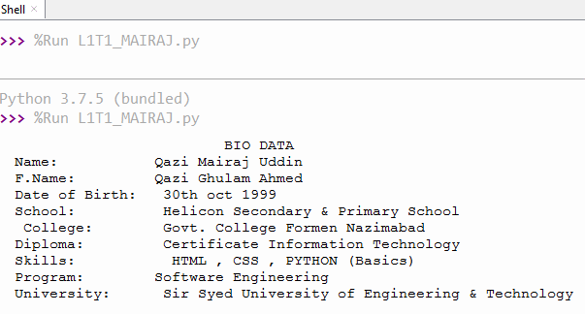

Headings: Times New Roman (size 16), Bold, Underline

Heading of **Source code** and **Output**: Times New Roman (size 20), Bold, Underline

Rest of all work: Times New Roman (size 12)

Code: Consolas (size 12)